**Abstract**

For my term project, I have chosen to analyze the video game sales dataset by generating visualizations, in the hope of gaining insight on the best selling video games across the globe. By insight I mean feasible inferences, like the year range or the favorable genre that is likely to make a game popular. I only used Tableau for generating graphs, which I combined them into a dashboard as the final product. By the end of it, I was able to deduce what the deciding factors are for the most successful games. I don’t doubt that there are many other confounding variables outside that would have affected my conclusions. Since the number of features is limited, my conclusions are solely based on the available information in this dataset.

**Source:**

<https://github.com/knpraveen/VideoGameSales/blob/master/vgsales.csv>

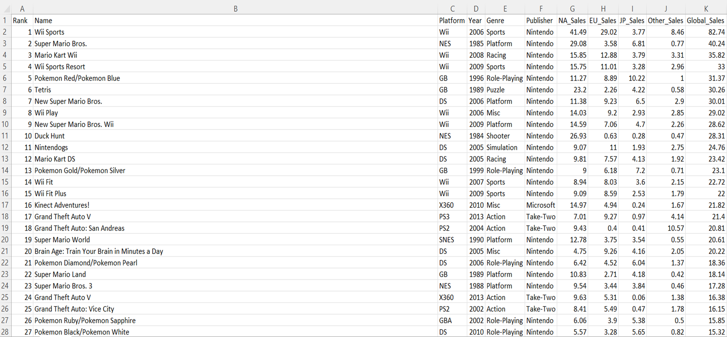

**Patterns/Findings**

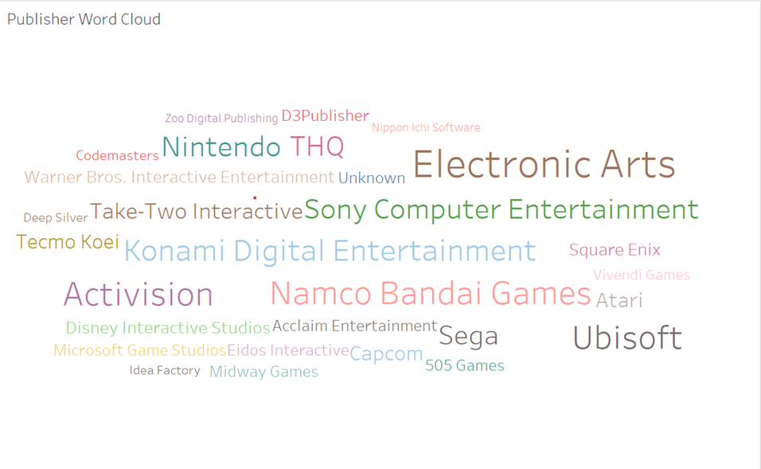



These two word clouds visualize the biggest video game publishers and the most popular genres.

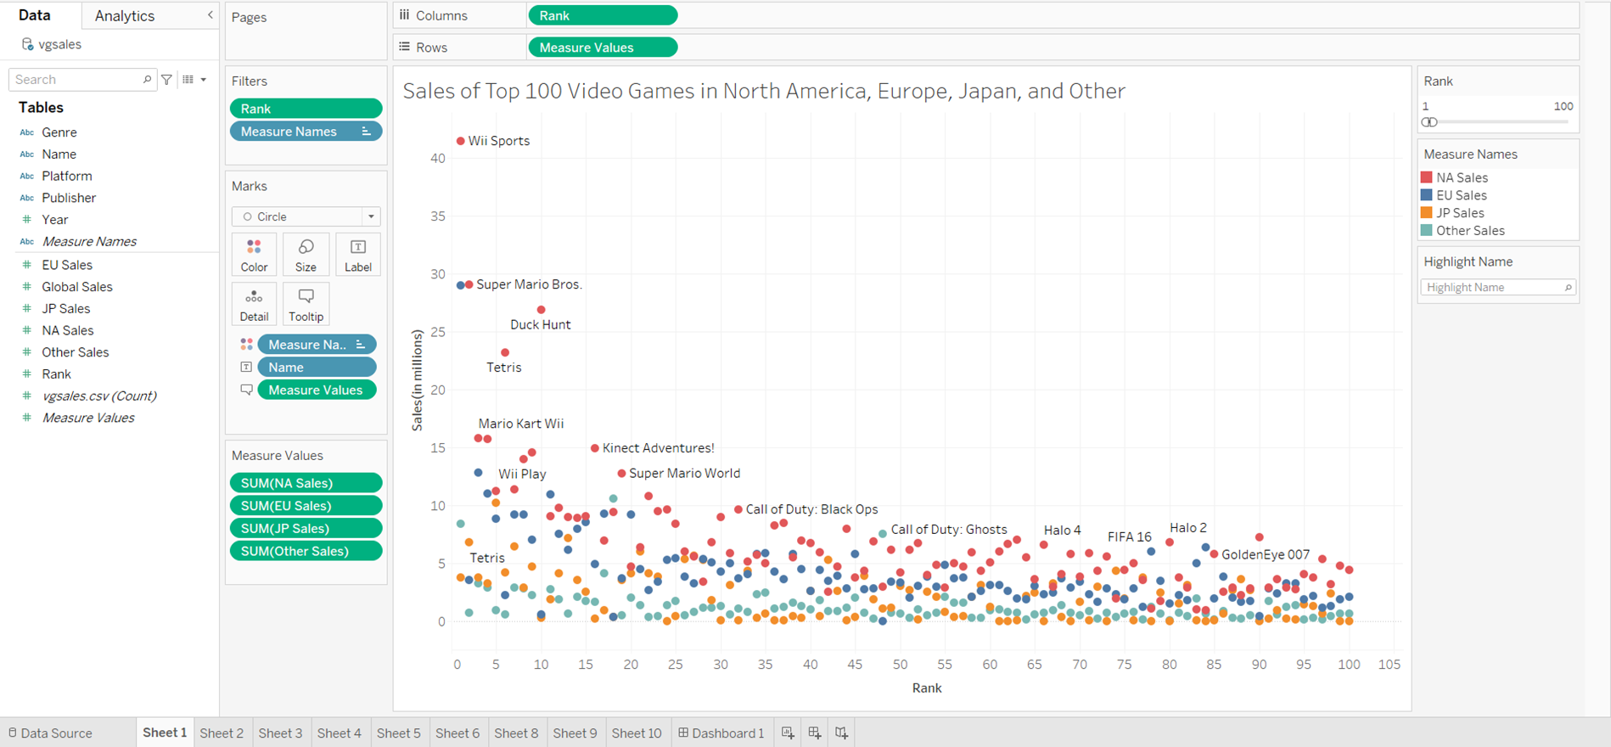

This is the first graph that compares sales amount of the top 100 best selling video games among the four regions. Since the regions are color-coded, we can clearly see that mostly red dots are on top. So it indicates that North America sold the most copies/generated the most revenues among the top 100 video games. Then it is followed by the blue dots, which represent the Europe region. We can then make the inference that the gaming culture is bigger in the West than in the rest of the world, without considering population and affordability etc. In addition, Wii sports, as well as other Wii games have great presence on the top 100 list, surprisingly. Wii Sports is a collection of five sports simulations, tennis, baseball, bowling, golf and boxing, using the motion-sensing and vibrating Wii Remote. It takes the number one spot, having 41.5 millions NA sales, 29 millions EU sales, 3.8 millions JP sales, 8.5 millions Other sales, which combines into 82.7 global sales overall shockingly. On the top 100 list, we also see many familiar Intellectual Property (IP) names like Super Mario, Pokemon, and Call of Duty.

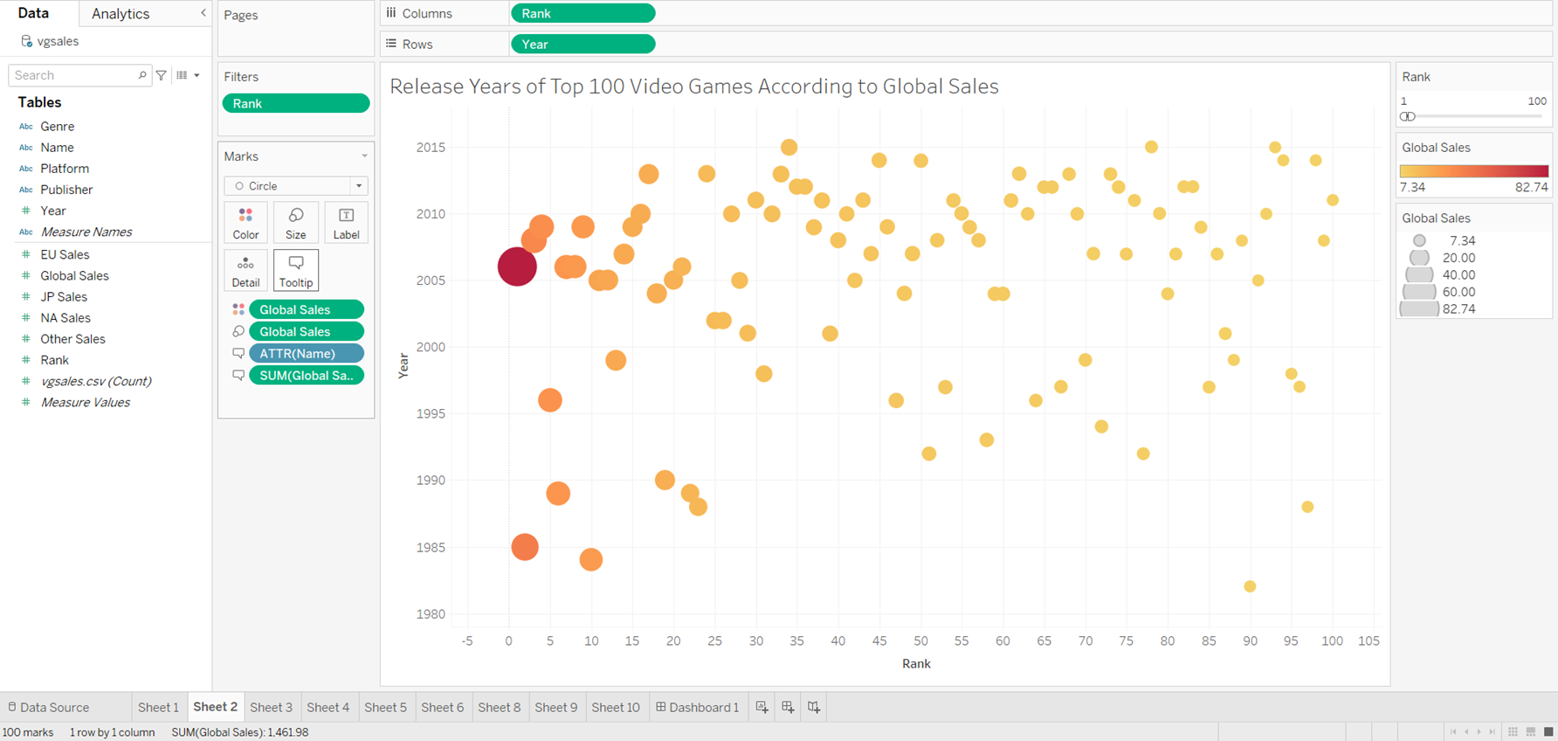

This is the second graph that shows the release years of the top 100 best selling video games, annotated by the global sales. Each dot’s color and size is determined by the global sales. So the more yellow or smaller the dot gets, the less the global sales amount, and vice versa. It is much akin to a heat map. We can notice a cluster of data in the upper left corner, where the top 10 ranked video games are located. We can then infer that some of the most popular games are made in the years from 2005 to 2010. Of course there are outliers in the lower left corner, where games like Super Mario Bros and Tetris were made in the 90s.

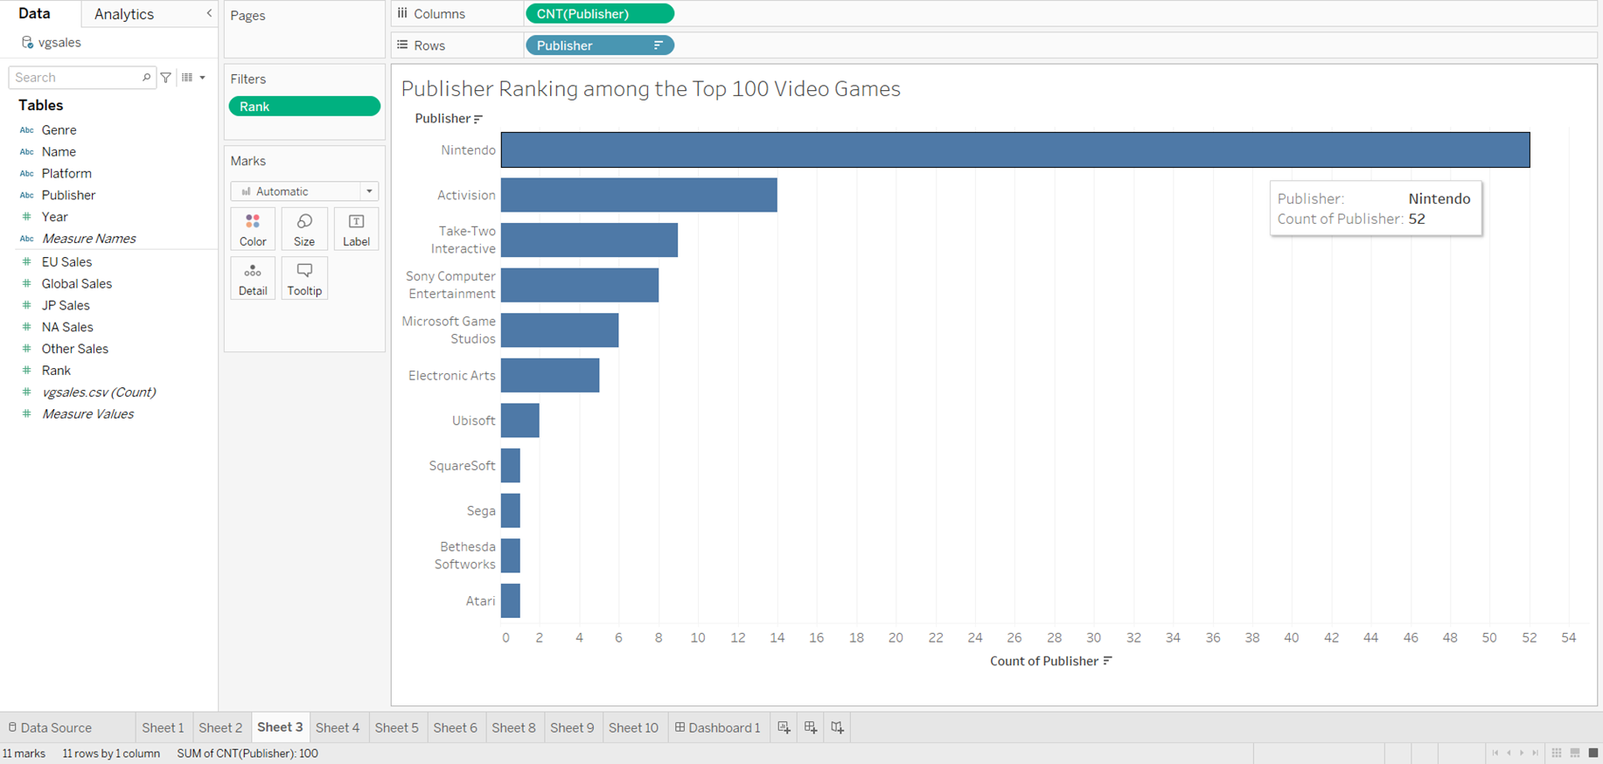

This is the third graph that ranks the publisher based on how many games they made in the top 100 video games list. Well, it confirms that Nintendo is indeed the biggest publisher/brand in the world, with an appearance rate of 52% in the top 100 list. The second on the list is Activision, who specializes in shooter games. When I think of Activision, I immediately think of the Call of Duty games. Also, the GTA series comes to mind first when I hear Take-Two Interactive, the third on the list. This graph is pretty intuitive and easy to follow.

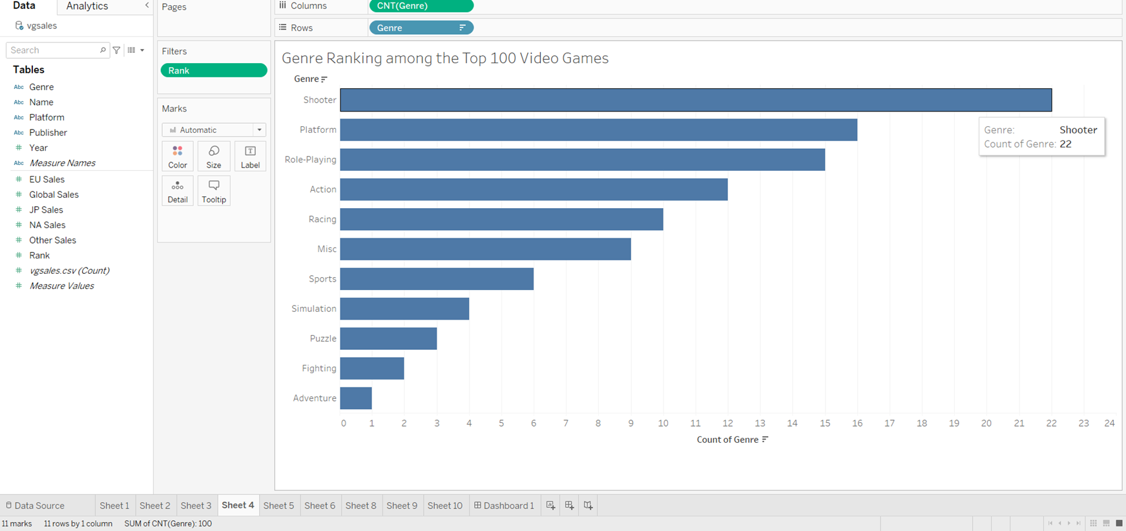

The fourth graph is much similar to the third graph. Instead of ranking the publisher, we are ranking the popularity of each genre in the top 100 best selling video games. Surprisingly, the shooter/FPS genre reigns supreme over the others. If we look closely at the dataset, most of the shooter games are part of the Call of Duty series. The same goes with the platform genre, it is mostly consisted of the Super Mario series. And there are a bunch of Pokemon games that belong to the role-playing genre in the top 100 list. Overall, I would say that this graph is not particularly useful considering the fact that the genre ranking is carried by big names.

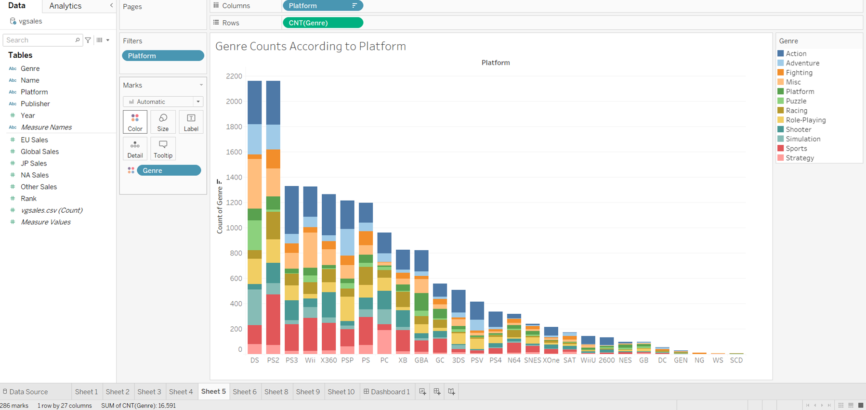

This fifth graph is a segmented bar chart. It is beautiful yet confusing at the first glance. It demonstrates the numbers of games classified by genres in each platform. On the up side, the genres are organized in alphabetical order and the color pattern from top to bottom is always consistent. Take the first platform DS for example, 343 games are in the action genre, 240 games are in the adventure genre, and 393 games are in the miscellaneous genre. I know that we can’t get the exact counts from merely looking at the graph. I plan to hover over the color segments on Tableau during my presentation so people can see the labels. By observing the color distribution, we can safely say that action and sports both take up big proportions of the top 5 platforms. The miscellaneous genre also needs to be mentioned, although I’m not entirely sure what kind of games fall into that category. I’d assume they are games that can fit into a variety of categories, so a mixture of genres. On a side note, we can also determine platform popularity based on this, ranging from DS to PS2 to PS3.

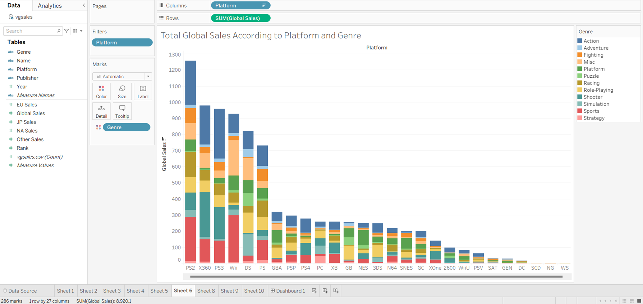

This sixth graph is very similar to the last graph, inheriting the segmented bar chart style. Instead of genre counts, now it is based on total global sales according to platform and genre. Same as before, both the action and sports genres take up a large portion of top 5 platforms. It is worth noting that the shooter genre takes up a huge chunk on Xbox 360, because of Halo and CoD I would assume. This graph therefore demonstrates what some of the platforms specialize in or what genres would do well in sales. For more examples, Wii specializes in making sports games, while DS specializes in making role-playing/simulation games. PS2 absolutely dominated the global market, reaching 1250 millions sales in total. Slightly different from the last graph, we can determine platform profitability on a global scale based on this graph.

**Conclusion/Summarization**

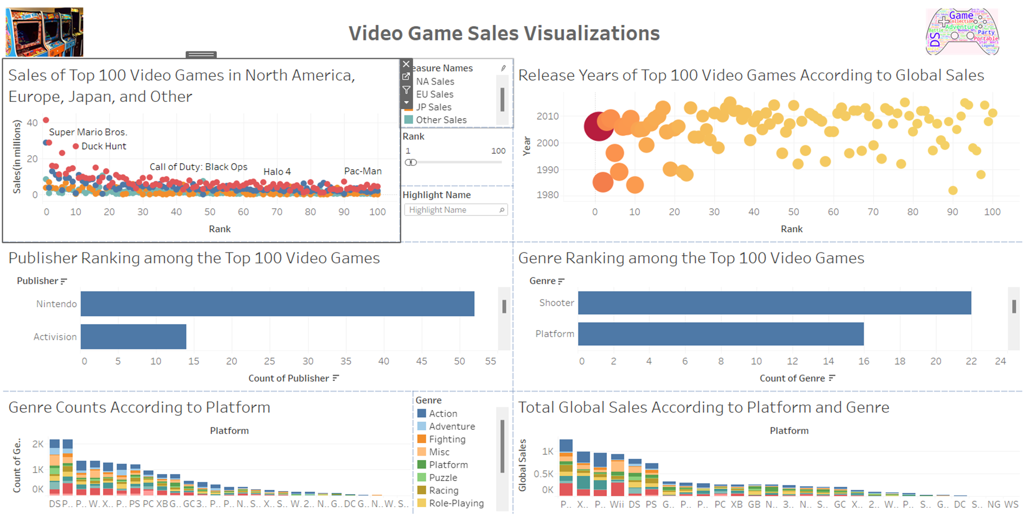

This is the final product where I put all six graphs together into a dashboard. To sum up, we’ve determined that NA sales is greater than EU sales, followed by JP sales and then Other region sales. The most popular games tend to be released around 2005 and are most likely made by Nintendo. The Call of Duty series solo carried shooter games to the top of the genre ranking. The segmented bar charts tell us the popularity level of each genre, as well as their respective platform’s popularity/profit level. Again, this project was done only using Tableau. Although I ran into a couple obstacles when making the graphs I wanted in Tableau, I gained a lot of experience and I was proud of how the final product came out to be.